BCEIA2019 International Summit on Analytical Instrumentation and In Vitro Diagnosis
--Registration in Progress
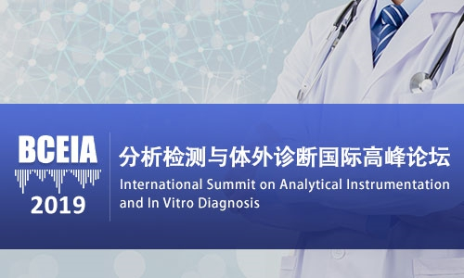
In recent years，In Vitro Diagnosis has become one of the fastest growing segments in the field of life sciences and clinical medicine worldwide. Statistics reveal that in 2018, the size of the global InVitro diagnosis market reached USD 80 billion while the Chinese market reached RMB 50 billion, representing an annual growth of 15%.
The rapid growth in the Chinese InVitro diagnosis market is driven by China's large population, the substantial growth of the economy, great population mobility, the increase in emerging infectious diseases，enhancement of people's awareness about health and the Government's development initiatives regarding the healthcare industry and biotechnology industrialization.
Market factors are driving the development of analytical sciences to focus more on InVitro diagnosis, and as a result, the usage of some analytical technologies such as mass spectrometers and digital PCR are experiencingincreasedusage in the early screening of cancer and nerve system diseases.
Analytical technology and testing methods are developing at an everincreasing speed. Mass spectrometry platforms have become the spotlight of Clinical medical examination, especially in microorganismidentification, neonatal screening and identification of tumor markers. Electrochemiluminescence technology is a new testing technology based on immunological technique, antibody technology and biotechnology, which has gained extensive application in clinical detection thanks to its characteristics of high sensitivity, strong stability, good repeatability and a highdegreeofautomation.
Small Molecule Testing has always been a strength of analytical technology but has been limited by various conditions of samples, and sample pre-treatment is always required. Based on the small molecule antibody technology and enzymology, Homogeneous Enzyme Immunoassay (HEIA) technology was developed to overcome the limitations on sample influences, and hence resolve the problem of mass clinical testing requirements. HEIA technology is well applied in tumors, metabolism and internal secretion diseases, and clinical sample testing has improved in terms efficiency and accuracy.
The “International Summit on Analytical Instrumentation and InVitro Diagnosis” specially invites renowned interdisciplinary experts to participate in debates on the development and application of analytical instruments and technology in the field of InVitro diagnosis, and the perspective of human health. The Summit will be one of the highlight events of BCEIA 2019.

International Summit on Analytical Instrumentation
and In Vitro Diagnosis
Agenda
Date: 23October, 2019 (09:30-12:45)
Location: InterContinental Beijing Beichen, China
Language: Chinese and English

Time | Content | Speaker
8:30-9:30 | Registration
9:30-9:40 | Opening Speech | Huwei Liu  Professor  Peking University
09:40-10:10 | Overview Report-Technology Innvoation and Hospital Developmen | Qimin Zhan  Professor  Academician of CAE  Peking University
10:10-10:40 | Single Cell Omics: Decoding Human Genome | Xiaoliang Sunney Xie  Professor  Academician of NAS, United States  Peking University
10:40-11:10 | Electrochemiluminescence Immunoassay and Its Application | Ying Zeng  EVP  Lifotronic Technology Co, Ltd
11:10-11:20 | Coffee Break
11:20-11:50 | Advancements in MS imaging for Biomedical Research | Emmanuelle Claude  Principal Scientist（Health Sciences Business）  Waters Corporation
11:50-12:20 | Applications of Homogeneous Enzyme Immunoassay (HEIA) for Small Molecule Testing | Liuming Yu  Chairman& CEO  Suzhou Evermed Biomedical Co, Ltd
12:20-12:30 | Closing Speech | Huwei Liu  Professor  Peking University

Guest Moderator
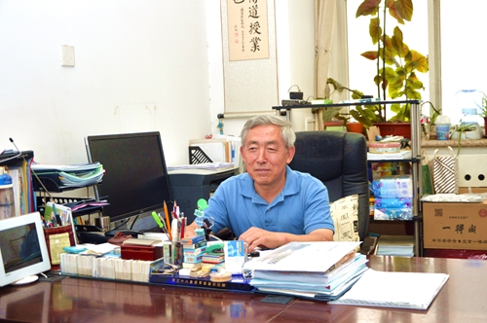
Huwei Liu
Huwei Liu is the Ph.D. Professor of Institute of Analytical Chemistry, College of Chemistry and Molecular Engineering, Peking University.
Dr. Huwei Liu graduated with a BA degree in 1982, and Ph·D· in 1990 from Beijing Institute of Technology (BIT), China, then he joined Peking University, became a full professor in 2001. His research work focuses on bioseparation and detection, including fundamentals and applications of chromatographic, electrophoretic separation techniques and mass spectrometry, as well as hyphenated methods such as LC-MS and CE-MS. The application areas cover pharmaceutical analysis, plan hormone detection, proteomics and lipidomics analysis. He is the author and co-author of more than 280 research papers and reviews, 3 books, and several chapter contributions of the edited books. He is currently a member of Chinese Chemical Society and American Chemical Society, a vice president of China Mass Spectrometry Society, president of Beijing Chromatography Society. Reputy Secnetany General of China Association for Instrumental Analysis (CAIA). He also serves as an associate editor of Journal of Separation Science and Journal of Analysis and Testing, an executive editor of Chinese Journal of Chromatography, an advisory/editorial board member for Analytical Chemistry(2013-2015), Analytical and Bioanalytical Chemistry, Molecules (Section Board for 'Analytical Chemistry') and other ten Chinese journals.

Keynote Speakers
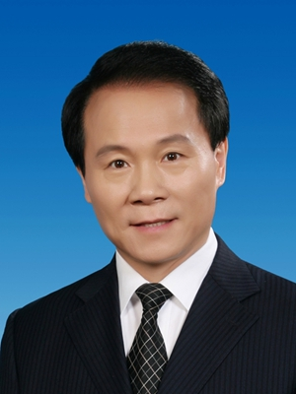
Qimin Zhan, MD

Qimin Zhan, MD, is currently an Academician of the Chinese Academy of Engineering, the Executive Vice President of Peking University, President of Peking University Health Science Center, President of Peking University Shenzhen Graduate School, and the Director of the State Key Laboratory of Molecular Oncology.
Dr. Zhan is the chairman of National Health Care Project and the chairman of National Biotechnology Development Strategy. He was the Chairman of the National Advisory Board for 863 High-Tech plan in the field of biomedical sciences and is the Chief Scientist of the 973 National Fundamental Program. Dr. Zhan’s research interest is focused on the molecular pathways involved in the control of cell cycle checkpoint and apoptosis after DNA damage, and the signaling pathways involved in regulation of the maintenance of genomic stability and tumor metastasis. In recent years, Dr. Zhan has paid great attention to the cancer translational study, including molecular diagnosis and personalized therapy. His research has successfully attracted multiple grants from different funding agencies. Dr. Zhan’s has published more than 240 peer-reviewed SCI papers. Many of his publications are in prestigious journals, including Nature, Cell, the Journal of Clinical Investigation, and others. To date, they have been cited more than 14,000 times.
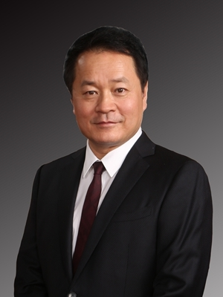
Xiaoliang Xie
Professor Xie is an internationally renowned biophysical chemist, and the Lee Shao-kee professor of Peking University. After a career at Pacific Northwest National Laboratory, he became the first tenured professor at Harvard University among Chinese scholars who went to the US since the Reform in China. As a pioneer of single-molecule biophysical chemistry, coherent Raman scattering microscopy, and single-cell genomics, he made major contributions to the emergence of these fields. In particular, his inventions in single-cell genomics have been used in in vitro fertilization to benefit hundreds of couples in China by avoiding the transmission of monogenic diseases to their newborns.
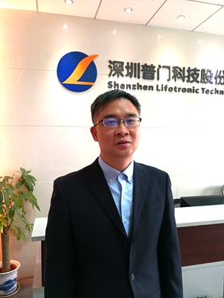
Ying Zeng
Mr. Zeng is the EVP of Lifotronic Technology Co., Ltd., who is in charge of the Research and Develop Department of the company.
IVD Division of Lifotronic has developed an electrochemiluminescence immunoassay system, a nephelometer immunoassay system, a lateral flow immunofluorescence analysis system, a HPLC HbA1c analysis system and a thrombelastogram analysis system. The nephelometer immunoassay system has won the first prize of the progress of science and technology in Shenzhen.
Healing products Division of Lifotronic developed wound treatment solutions, have won the first prize of the national award of the progress of science and technology.
Mr. Zeng has also worked in GE Healthcare,China and Shenzhen Mindray Biomedical Electronics Co., Ltd for nearly 20 years.
Emmanuelle Claude
Miss Emmanuelle Claude (Master in Fine Chemistry and Business and P.Phil in spectroscopy analysis in organic chemistry and biology) has started at Waters Corporation in October 2000 as an Application Chemist in the Proteomics and Genomics Marketing group, developing automated Peptide Mass Fingerprint (PMF) MS methods using a MALDI-TOF mass spectrometer.
Over the years she developed a number of methods in the proteomics analytical space using MALDI TOF and naturally moved in starting the development of Mass Spectrometry Imaging (MSI) at Waters corporation over 12 years ago.
She has been involved with hardware and software R&D to ensure that the solutions were fit-for-purpose for the MSI community. She has worked extensively with the main MSI leaders in Europe and the US such as Prof Heeren in the Netherlands, Prof Clench, Prof Takats and Bunch in the UK and Prof Caprioli in the US. She has been a Principal Scientist since 2014 and is managing the MS imaging application team at Waters where data are generated for marketing (i·e·application literature, customer presentation, papers, posters...), hardware and software requirements are defined for the R&D teams. The team evaluates and develops new applications & methods for Imaging by both MALDI and DESI mass spectrometry。
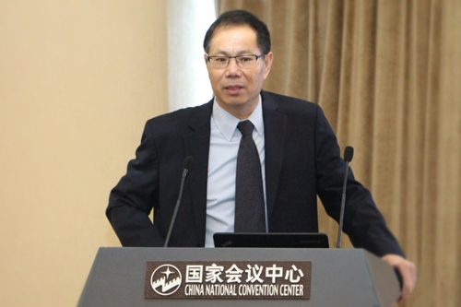
Liuming Yu

Mr. Yu is the Chairman & CEO of Suzhou Evermed Biomedical Co., Ltd (“Evermed”). He is a well-known expert in development of liquid reagents for measurement of small molecules using Homogeneous Enzyme Immunoassay (HEIA) methodology. Prior to his tenure at Evermed he held a prestigious position as the R&D Director at Quest Diagnostic, the largest reference laboratory in the world. He also served as the inspector and the Chinese ambassador of CAP (College of American Pathologists). Since founding Suzhou Evermed in 2012 he headed his company to develop more than 100 HEIA assays, acquired more than 30 China invention patents, and successfully received cFDA approvals for twelve clinical HEIA products. His achievements were recognized and won multiple local and national awards including: “National Torch Plan”, “Jiangsu Science and Technology Achievement”, “Jiangsu Double-Creation Reward”, and “Suzhou Leadership Award”. In 2013 Evermed was the first IVD company in China to utilize the HEIA methodology for clinical diagnostic testing. Within a few years, HEIA products have been widely accepted by many clinical laboratories in China. Tested analytes include a broad range of clinical markers covering: Therapeutic Drug Monitoring (TDM), Endocrines, Metabolites, Drugs of Abuse (DOA), and Adulterants.

Contact Person
Ms. Liying Wang
Phone:+86-10-6851 2289
E-mail: liying.wang@caia.org.cn

Register Here

Scan the QR code
About BCEIA:
Sponsored by CAIA (China Association for Instrumental Analysis), the Beijing Conference and Exhibition on Instrumental Analysis (BCEIA) is a highly specialized and well respected international analytical instruments conference and exhibition in China. After being held for and developed over 30 years, BCEIA is becoming more renowned worldwide, with exhibitors and participants coming from over 20 and 30 countries respectively, to participate in the great event on a biennial basis. In 2017 the number of registered participants exceeded 25,000, and the registered experts for the Academic Conference reached 3,400.
The 18th Beijing Conference and Exhibition on Instrument Analysis (BCEIA2019) is scheduled to be held from 23rd to 26th October, 2019 at the China National Convention Center, Beijing, China. With the vision of “Analytical Science Creates Future”, BCEIA 2019 will continue to host academic conferences, summits, forums and exhibition under the theme of “Moving Towards a Green Future”.

